Quality, security & production readiness research
Assignment 3

Team Members:
Hermanus Jacobus Bantjes (601427)
Jason Crous (601662)
Zander De Groote (602789)
Belgium Campus iTversity
SEN381

Question 1: Quality Strategy & Risk-Based Verification

Introduction
Software quality should not be treated as an activity performed only after implementation. A quality strategy should establish quality expectations early, identify risks that could cause significant failure, and then allocate verification effort according to those risks.
This is particularly relevant to CivicConnect because it is a web-based information system responsible for service requests, requester visibility, staff workflow, management information and potentially sensitive information.
A defect in a cosmetic interface element does not necessarily have the same consequence as a defect that allows a requester to see another user's service request or causes a submitted request to disappear.
The International Software Testing Qualifications Board (ISTQB) identifies risk-based testing as an approach in which test activities are selected, prioritised and managed using risk analysis and risk control. It also identifies risk likelihood and risk impact as the two basic attributes used to express risk level (International Software Testing Qualifications Board - ISTQB®, 2026, p. 51).

Therefore, a sensible quality strategy could be:
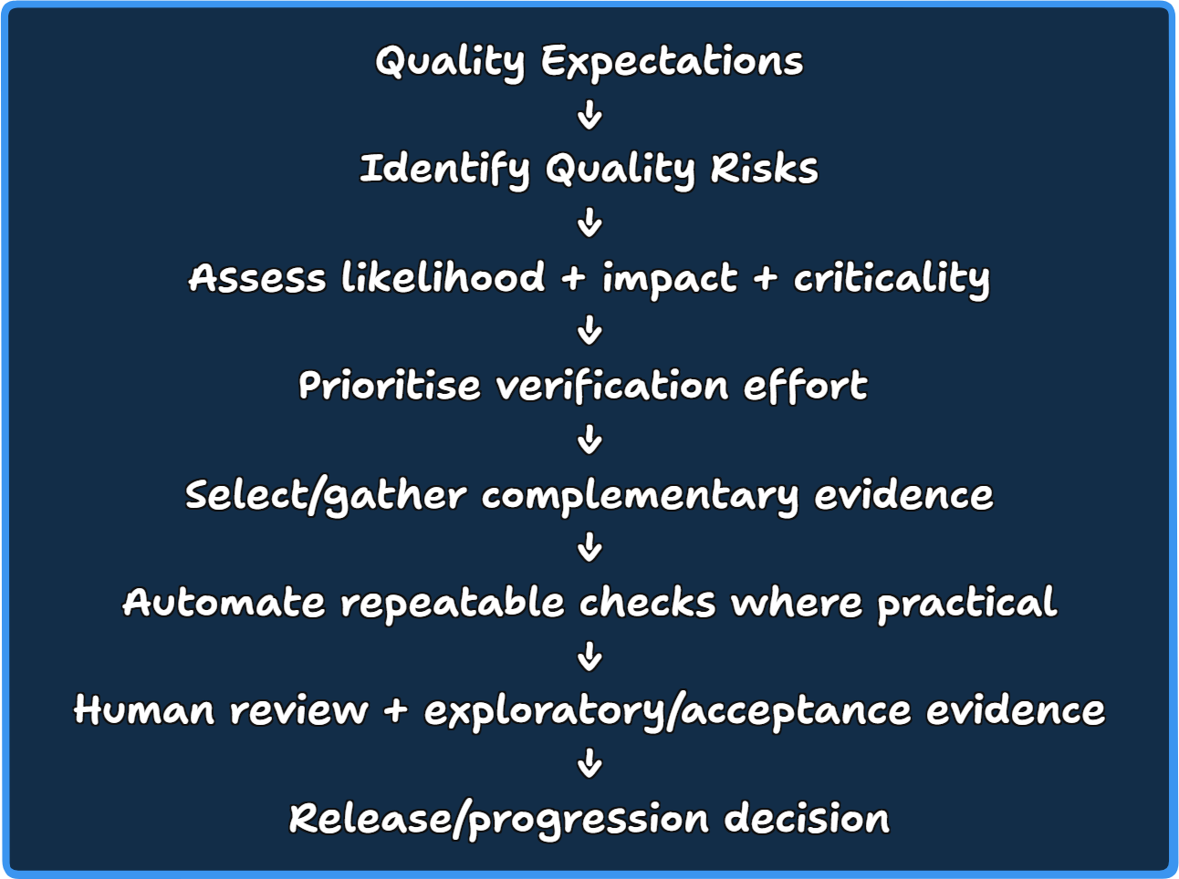
This strategy gives our team a basis for later milestone decisions, without assuming that a single test type can demonstrate every quality characteristic.

2. QA, QC, Verification and Validation

2.1 Quality Assurance (QA)
Quality Assurance primarily focuses on establishing and maintaining processes that provide confidence that quality requirements will be met.
ISO describes QA as a systematic activity that supports consistent quality, while also explaining that QA is intended to provide confidence that quality requirements will be fulfilled (International Organisation for Standardisation- ISO, 2026).

For software engineering, QA therefore concerns questions such as:
- Are requirements sufficiently clear and testable?
- Are development and review practices defined?
- Are changes controlled?
- Are quality checks performed throughout development?
- Is evidence recorded consistently?
For CivicConnect, QA would therefore influence the process surrounding development, rather than only the finished application.

2.2 Quality Control (QC)
Quality Control focuses more directly on evaluating the resulting product against defined quality requirements.
Daniel Galin distinguishes QA as process-oriented, and QC as concerned with evaluating whether outputs fulfil quality requirements (Galin, 2018, p. 17).
For CivicConnect, QC could include:
- executing tests;
- inspecting test results;
- checking whether acceptance criteria have been satisfied;
- identifying defects;
- checking measured performance against defined targets.

Concept | Main Question | CivicConnect Example
QA | Are we using processes that support quality? | Are requirements reviewed and acceptance criteria defined before implementation?
QC | Does the resulting product meet its quality requirements? | Does the request-submission function satisfy its acceptance criteria?
Verification | Did the product/work conform to its specified requirements? | Does the implemented status workflow conform to the requirements?
Validation | Does the product meet its intended purpose and user needs? | Does CivicConnect support a requester in submitting and tracking a service request effectively?

3. Verification and Validation (V&V)
IEEE Standard 1012 defines V&V as processes used to determine whether development products conform to the requirements for their activity and whether the resulting product satisfies its intended use and user needs. The current IEEE 1012-2024 standard was approved in 2025 and applies V&V across the system/software life cycle (IEEE Xplore, 2025).
NASA expresses the distinction more simply:
Verification asks whether we are building the product right, while validation asks whether we are building the right product (NASA, 2026).

For CivicConnect specifically:
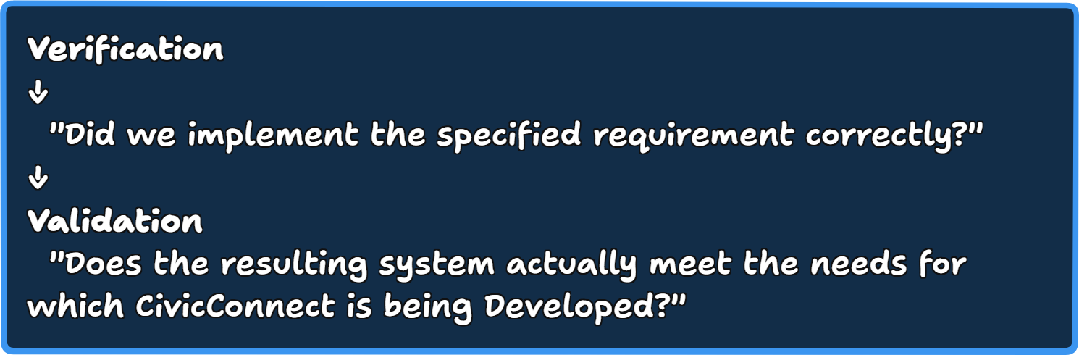
These activities complement QA and QC rather than replacing them.

4. Risk-Based Verification

4.1 Why test everything equally?
Testing resources are limited. ISTQB explicitly identifies exhaustive testing as impossible except in trivial situations. Instead, test techniques, prioritisation and risk-based testing are used to focus effort. ISTQB also notes that early testing can reduce downstream cost and that defects often cluster in particular components (International Software Testing Qualifications Board - ISTQB®, 2026, p. 53).

This means a quality strategy should not simply say:
"Every component gets the same number of tests."
Instead:
Higher-risk functionality should receive deeper and more diverse verification evidence.

5. Likelihood and Impact:
ISTQB defines two fundamental risk attributes:
Likelihood — probability that the risk occurs.
Impact — consequence or harm if it occurs.
These together express the risk level. Higher-risk areas require greater attention (International Software Testing Qualifications Board - ISTQB®, 2026).
Conceptually:

The actual assessment should also consider business and technical criticality.
For example, consider two hypothetical CivicConnect defects:
Risk | Likelihood | Impact | Criticality | Verification Implication
Incorrect colour on a status label | Medium | Low | Low | Basic UI/system verification may be sufficient
Requester can access another user's request | Low/Medium | Very High | Very High | Requires significantly deeper verification and security-focused testing
Request disappears after successful submission | Low/Medium | High | High | Requires persistence/integration/system verification
Dashboard takes slightly longer to load | Medium | Medium | Medium | Performance evidence may be appropriate

The important point is that likelihood alone should not determine testing depth.
A relatively unlikely failure can still deserve substantial verification when its consequences are severe.
The 2026 ISTQB Test Management material explicitly reinforces this principle by explaining that risk prioritisation should consider combined risk exposure rather than likelihood alone (International Software Testing Qualifications Board - ISTQB®, 2026).

6. Applying Risk-Based Verification to CivicConnect
An illustrative description of our team's process could be:
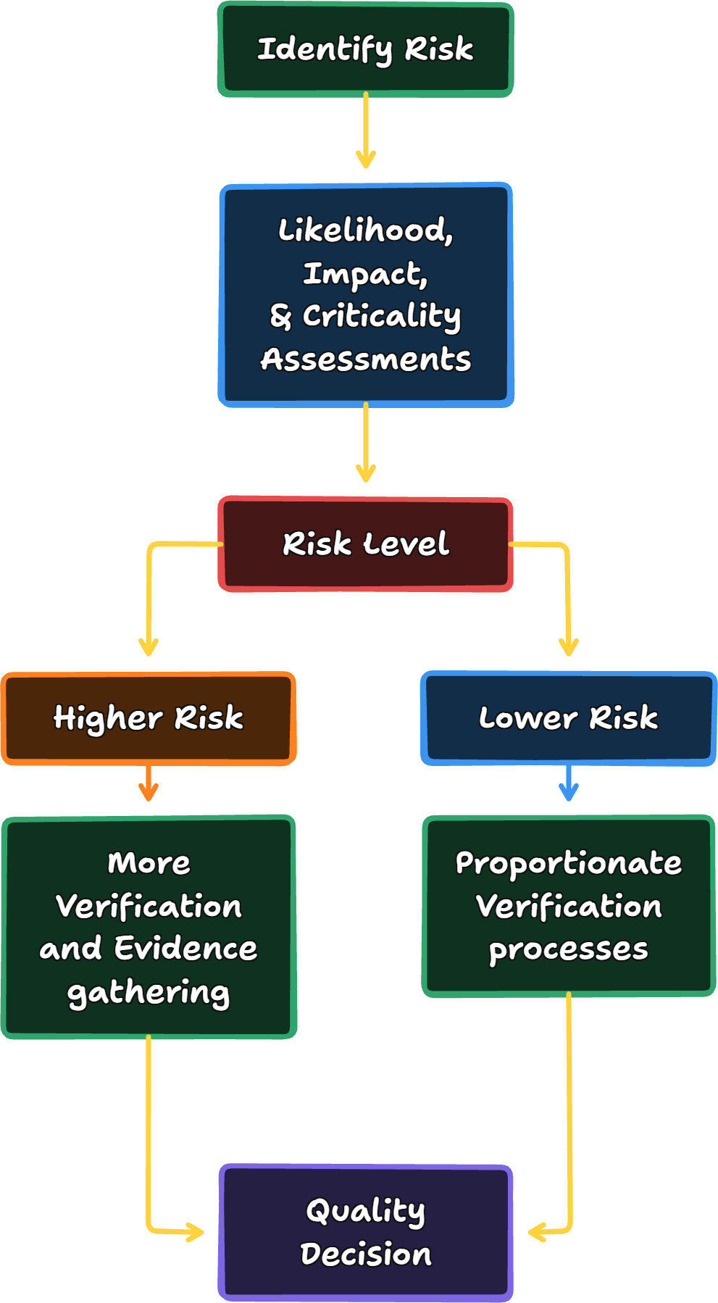
This serves as a research model, not yet CivicConnect’s final M3 risk scoring or test strategy.

7. Complimentary Verification Evidence:
Some of the forms of verification evidence our team has considered are as follows:
- Unit testing
- Integration/API testing
- System/end-to-end testing
- Static analysis/review
- Performance/load testing
NASA identifies unit, integration and system testing as different testing levels and also recognises performance, load, stress and acceptance testing as distinct testing activities (NASA, 2022).

7.1 Unit Testing:
Purpose
Unit tests verify small, isolated pieces of software such as functions, methods or classes.
For CivicConnect, examples could eventually include:
- request validation;
- status-transition rules;
- request categorisation logic;
- date/overdue calculations;
- permission-related business logic.
NASA notes that unit-level testing is performed on individual units and is useful because integration can make some component-level inputs and outputs less directly accessible (National Aeronautics and Space Administration, 2004, p. 184).
Strong at exposing
- Logic errors
- Incorrect calculations
- Boundary conditions
- Incorrect individual method behaviour
- Local regression defects
Cannot prove on its own
Unit testing does not demonstrate that:
- components integrate correctly;
- the database works correctly;
- API contracts are correct;
- the complete user workflow works;
- users can use the system effectively.
Therefore:
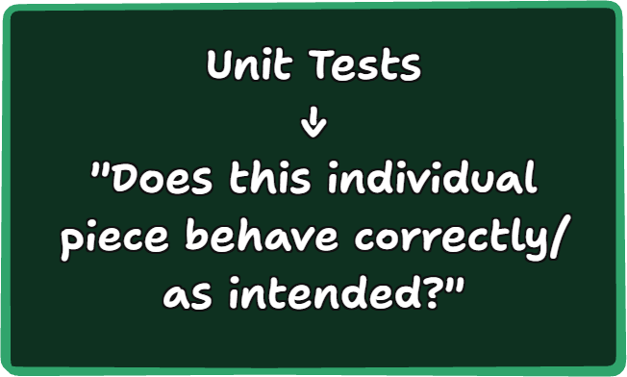
Represents better reasoning than:
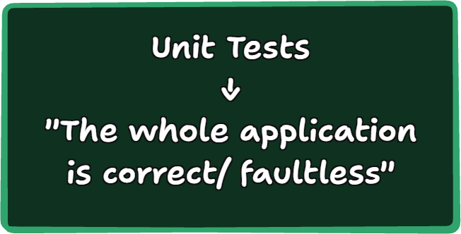

7.2 Integration/ API Testing:
Integration testing examines interactions between components.
For CivicConnect, this could include:
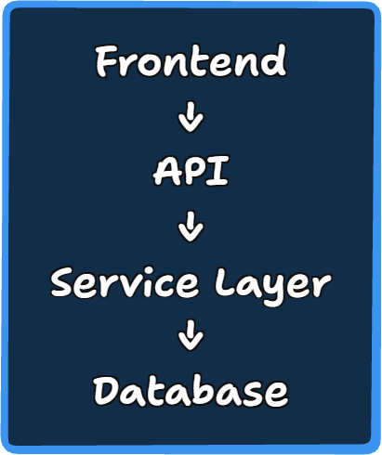
An API/integration test could verify that submitting a request through an API results in the expected service-layer and persistence behaviour.
Strong at exposing
- Incorrect API contracts
- Data-format mismatches
- Integration defects
- Incorrect authentication/authorisation integration
- Database interaction problems
- Communication failures
Cannot prove on its own
Integration testing cannot demonstrate that:
- the entire user journey works;
- the interface is understandable;
- all business scenarios are covered;
- performance is adequate under realistic load.

7.3 System/ End-to-End Testing:
System testing evaluates the integrated application as a complete system.
For CivicConnect, an example journey could be:
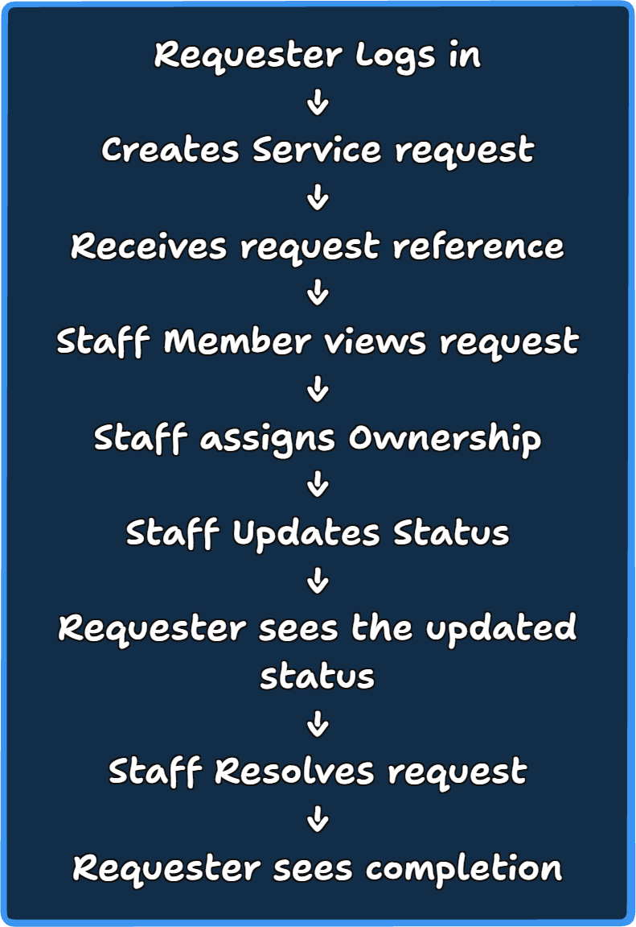
Strong at exposing
- Broken end-to-end workflows
- Incorrect integration between layers
- Incorrect UI-to-backend behaviour
- Missing functionality
- Realistic user-flow defects
Cannot prove on its own
End-to-end tests do not establish complete quality because they are generally:
- slower;
- more expensive to maintain;
- more vulnerable to environmental problems;
- capable of covering only a finite number of scenarios.
Martin Fowler's discussion of the Test Pyramid highlights that broad end-to-end tests can be slower, more brittle and more expensive than more focused tests, which is why different testing levels should complement rather than replace one another (Fowler, 2012).

7.4 Static Analysis and Review:
Static testing evaluates work products without executing the software. ISTQB includes reviews and tool-supported static analysis and notes that these techniques can assess aspects such as correctness, completeness, consistency, readability and testability (International Software Testing Qualifications Board - ISTQB®, 2026, pp. 20-21).

For CivicConnect, this could involve:
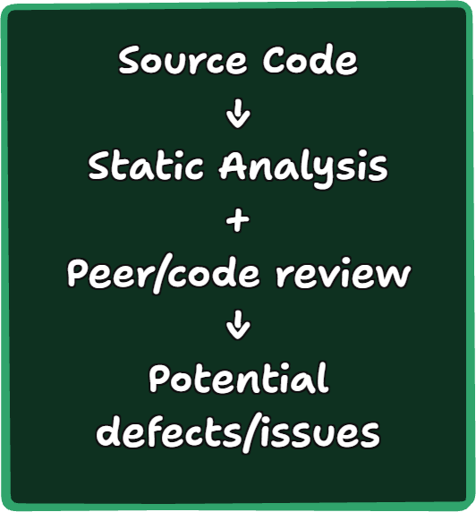
Strong at exposing
- Code quality issues
- Certain defect patterns
- Complexity
- Style violations
- Some security weaknesses
- Maintainability problems
- Inconsistent implementation
Cannot prove on its own
Static analysis cannot prove:
- correct runtime behaviour;
- complete functionality;
- satisfactory user experience;
- correct behaviour under realistic load;
- that every possible integration scenario works.
This is particularly important because static analysis examines artefacts without executing the system.

7.5 Performance/ Load Testing:
Performance testing examines behaviour under defined workloads.
For CivicConnect, potential concerns include:
- request-list response times;
- concurrent users;
- management reporting;
- API response performance.
Strong at exposing
- Slow response times
- Resource bottlenecks
- Capacity limitations
- Performance degradation under load
Cannot prove on its own
A successful load test cannot prove:
- functional correctness of every workflow;
- security;
- usability;
- absence of defects in other parts of the application.
NASA identifies performance, load, and stress testing as distinct forms of system-level testing used to meet relevant requirements (NASA, 2022).

Comparison Table for Verification Evidence:
Evidence Type: | Strong at Exposing: | Main Limitation: | Typical Risk addressed:
Unit Testing: | Local logic defects and edge cases | Does not verify component interaction | Incorrect validation/status logic
Integration/API Testing: | Interface, data flow, and service/database integration defects | Does not establish full user experience | API contract or persistence failure
System/E2E Testing: | Complete user journeys and cross-component defects | Slower, brittle and finite coverage | Broken request lifecycle
Static analysis/review: | Code-quality issues and certain defect patterns | Cannot prove runtime behaviour | Maintainability/security/code defects
Performance/load Testing: | Response-time and capacity problems | Does not verify general functionality | Slow or unstable system under load

The key conclusion is:
These forms of evidence complement each other because each observes different failure modes.

8. Suggested Evidence Pyramid:
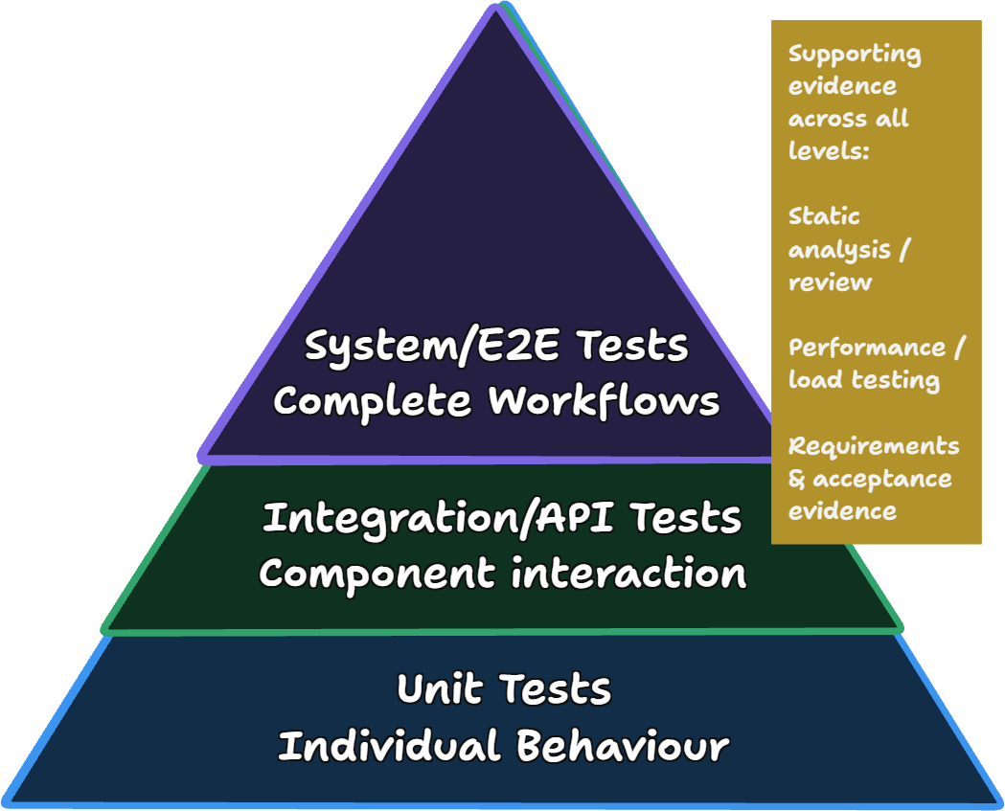
This helps indicate that different evidence operates at different levels.

9. Automation and Quality Gates:
Automation can make verification more repeatable.
For example:
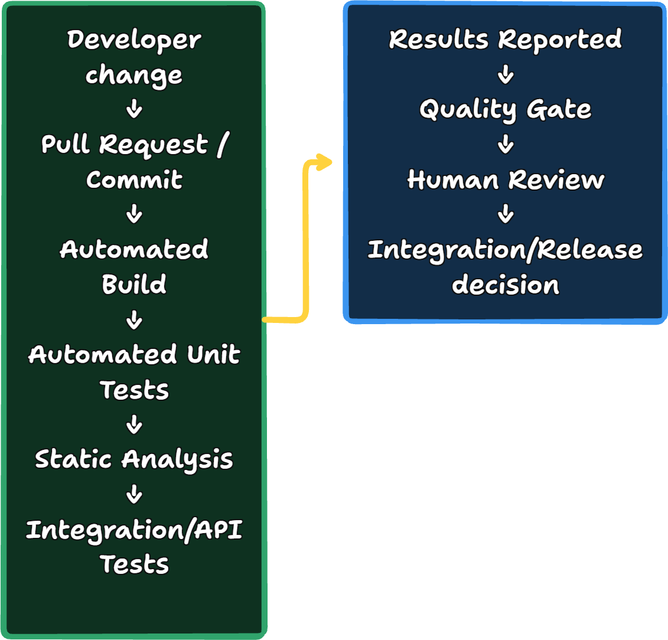
GitHub describes status checks as mechanisms that can validate commits through builds, tests, code scanning and deployment checks, with required checks able to prevent merging when configured as required (Github corporation, 2026).
This demonstrates how quality gates can convert individual checks into a repeatable engineering process.

10. What should a Quality Gate do?
A quality gate should be treated as a decision control, not a declaration that the software is perfect.
A conceptual example:
Check: | Possible Role:
Build/compile | Block integration if it fails
Unit Tests | Block if required tests fail
Integration Test | Block if critical interfaces fail
Static Analysis | Block on agreed critical findings; warnings may require review
Performance Test | Block a release where defined performance criteria are not satisfied
Human Review | Required even when automation passes

The exact checks and blocking thresholds would need to be decided later for CivicConnect based on its actual architecture, requirements and risks.

11. Why a Green Pipeline Is Not Proof of Complete Quality:
A pipeline can say:
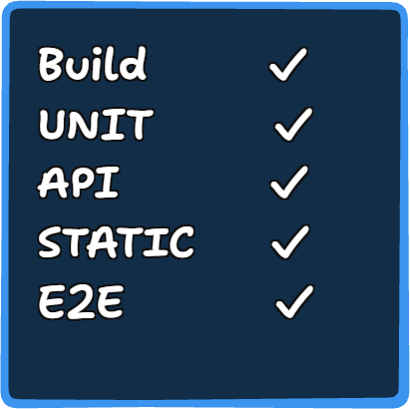
but this only means:
The configured checks passed under the conditions in which they were executed.
It does not mean:
"There are no remaining defects."
ISTQB explicitly states that exhaustive testing is impossible, while NASA notes that testing can demonstrate the presence of defects but cannot establish their complete absence. NASA also points out that even high code coverage does not by itself prove that all requirements have been tested (International Software Testing Qualifications Board - ISTQB®, 2026) (NASA, 2022).
There are several reasons.
1. Tests only cover scenarios that were designed
A test suite cannot automatically discover every unanticipated input, environment or user behaviour.
2. Tests themselves may be inadequate
A test can pass while failing to detect the defect it was intended to detect. Google Engineering Practices explicitly states that tests need human review and that reviewers should consider whether tests are valid, useful and capable of failing when the software is broken (Github Corporation, 2026).
3. Passing tests do not establish usability
An application could pass automated functional tests while being confusing or inefficient for real users.
4. Test environments may differ from real environments
A passing development/test environment does not automatically establish that behaviour will remain correct under production conditions.
5. Requirements themselves may be incomplete
A system can correctly implement an incorrect or incomplete requirement.
That is why validation and stakeholder/user evidence remain important. IEEE's V&V definition specifically includes intended use and user needs, not merely conformance to implementation requirements (IEEE Xplore, 2025).
6. Some quality attributes require different evidence
A successful functional test does not establish performance, security, maintainability or reliability.
ISO/IEC 25010:2023 provides a product-quality model that’s designed to give teams a reference for specifying, measuring and evaluating different quality properties rather than reducing quality to functional correctness alone (ISO/IEC JTC 1/SC 7, 2023).

12. Risk-to-Verification Evidence Map:
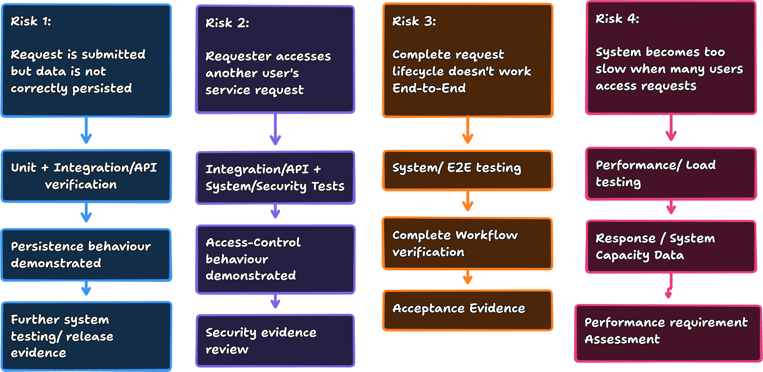

13. Putting the Quality Strategy Together:
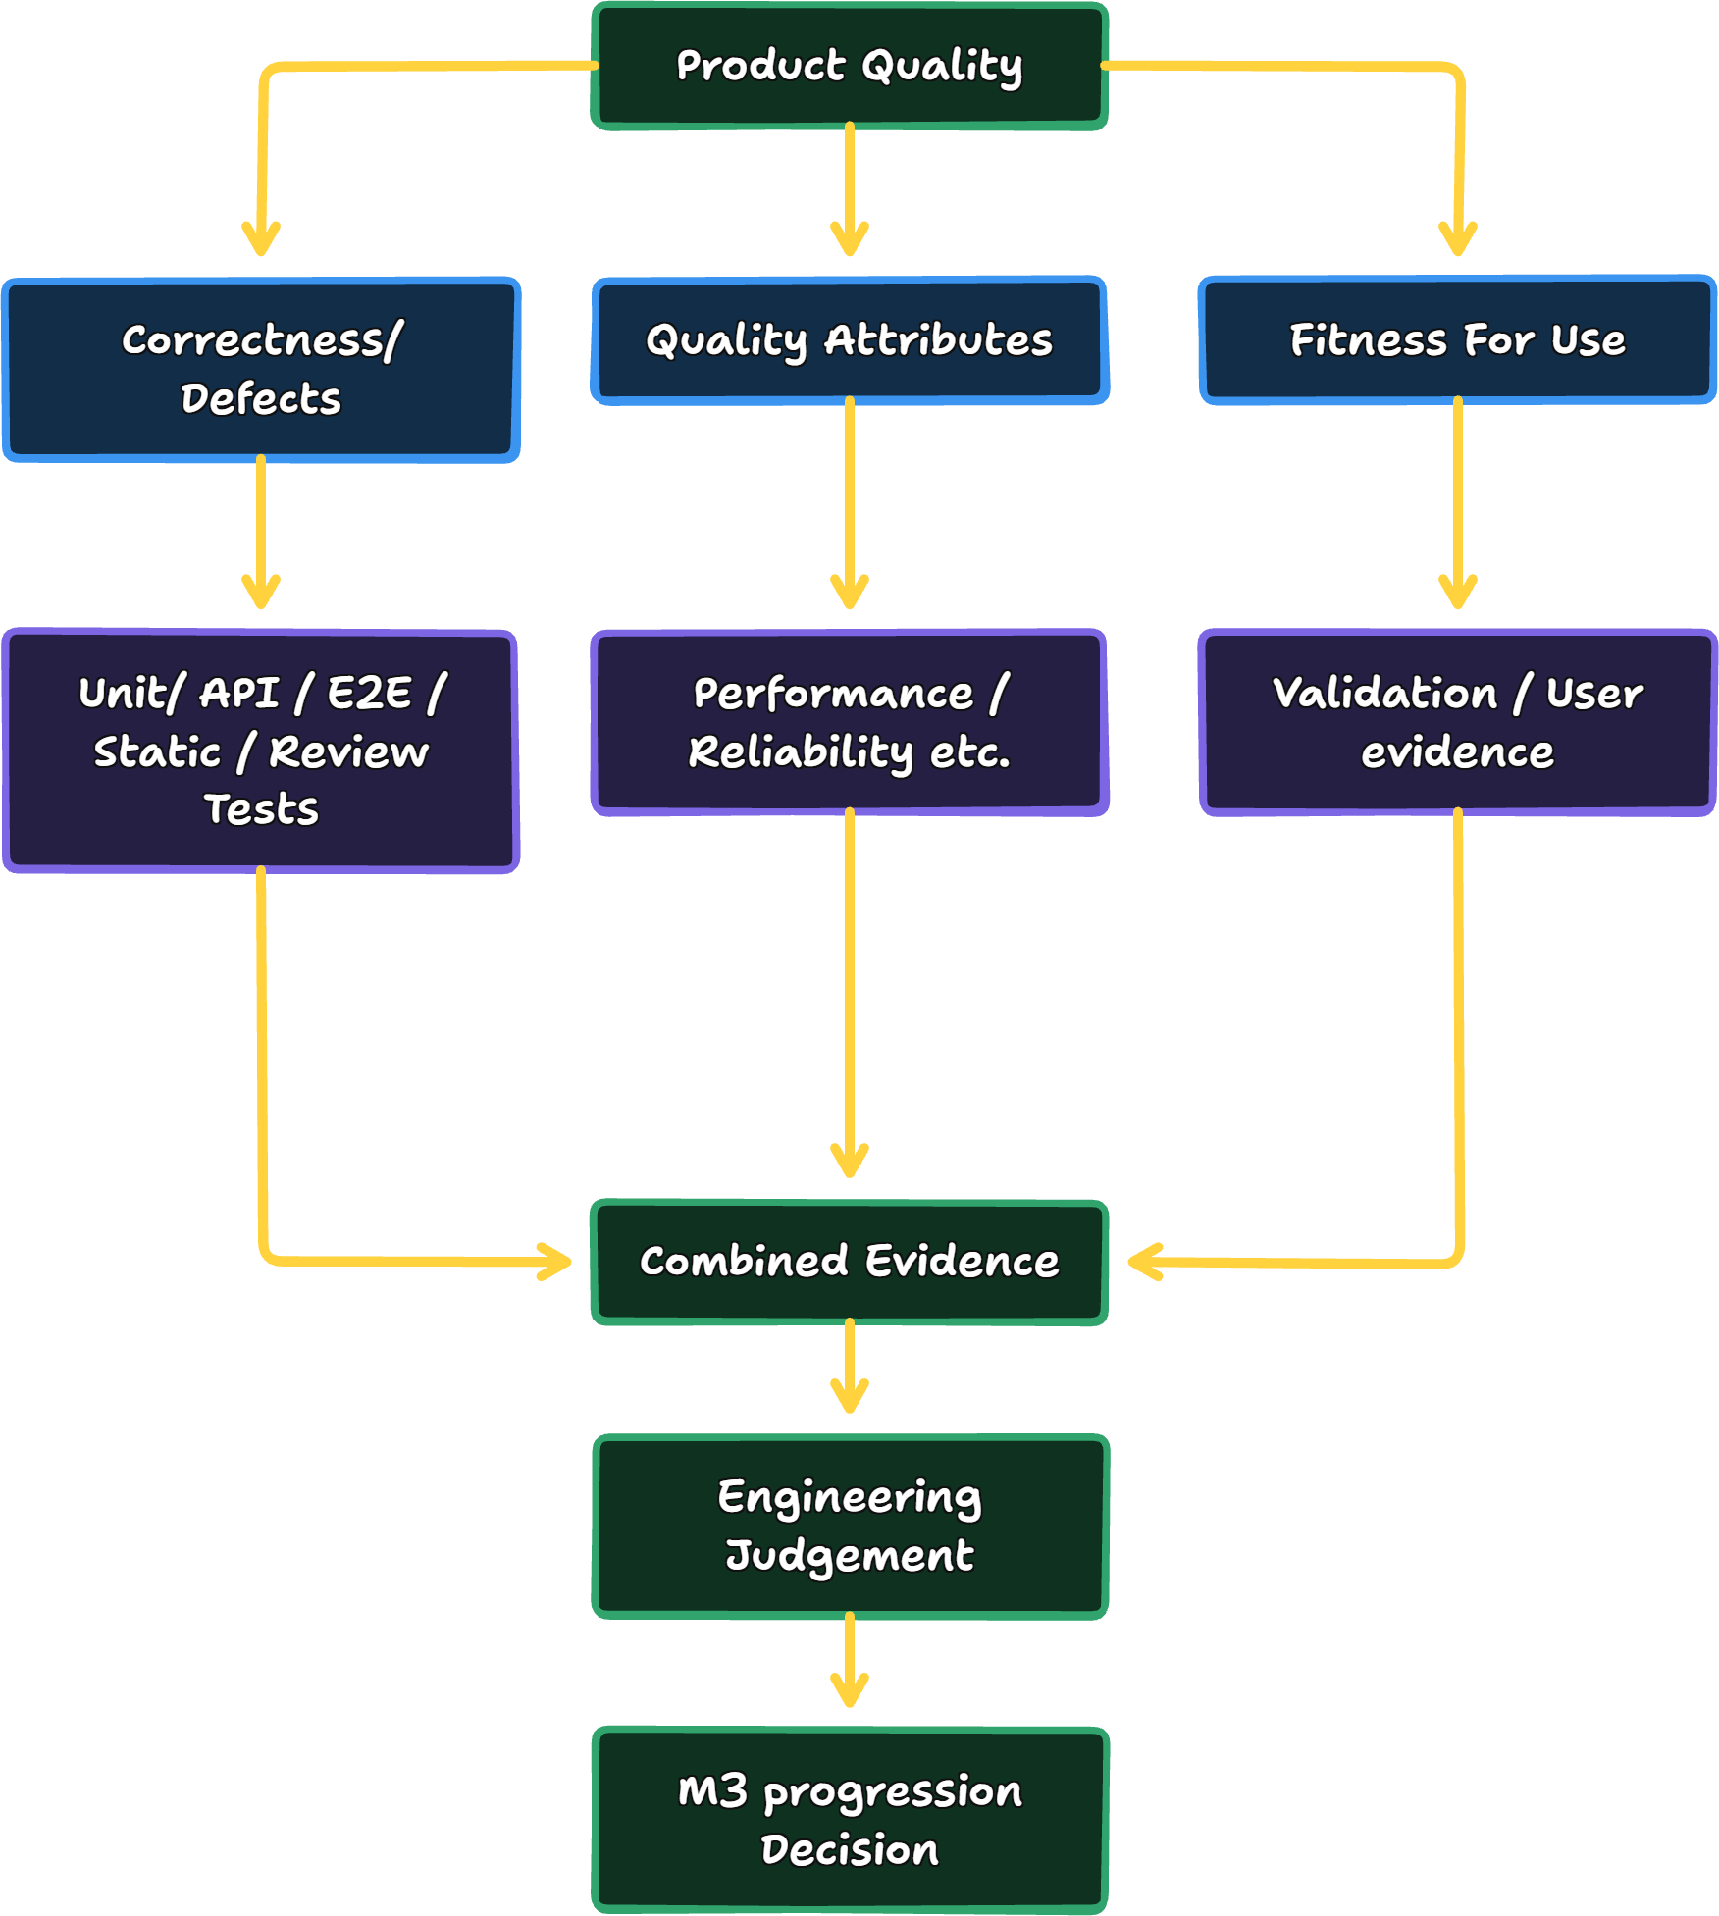

14. Conclusion for Question 1:
A risk-based quality strategy is preferable to treating all verification activities as equally important because software systems contain different levels of business and technical risk. Likelihood, impact and criticality can be used to determine where deeper and more diverse evidence is justified.
QA, QC, verification and validation contribute different but complementary perspectives: QA establishes processes that support quality, QC evaluates the resulting product, verification determines conformity to specified requirements, and validation considers intended use and stakeholder needs.
No individual verification technique provides complete assurance. Unit testing provides focused evidence about individual components, integration/API testing examines interactions, system testing examines complete workflows, static analysis can identify certain defects without executing the system, and performance testing provides evidence about behaviour under defined workloads. Their limitations mean that a defensible quality strategy requires complementary evidence rather than a single test type.
Automation and quality gates can make repeatable checks consistent and visible, but a green pipeline should be interpreted as evidence that the configured checks passed—not proof that the product is defect-free or production-ready. ISTQB's principle that exhaustive testing is impossible and NASA's guidance concerning the limits of testing reinforce the need for risk-based selection and human judgement (International Software Testing Qualifications Board - ISTQB®, 2026) (NASA, 2022).
For CivicConnect, these findings should therefore inform, rather than prematurely determine, the M3 quality strategy. The team will still need to assess its actual requirements, architecture, implementation, risks and available evidence before deciding which verification activities and quality gates should become part of the project baseline.

References
Fowler, M., 2012. martinFowler.com. [Online]
Available at: https://www.martinfowler.com/bliki/TestPyramid.html?
[Accessed 24 September 2026].
Galin, D., 2018. Software Quality: Concepts and Practice. illustrated ed. Chicago: John Wiley & Sons, 2018.
Github corporation, 2026. Github Docs. [Online]
Available at: https://docs.github.com/en/pull-requests/reference/status-checks?
[Accessed 24 September 2026].
Github Corporation, 2026. google.github.io/eng-practices. [Online]
Available at: https://google.github.io/eng-practices/review/reviewer/looking-for.html?
[Accessed 24 September 2026].
IEEE Xplore, 2025. IEEE Standard for System, Software, and Hardware Verification and Validation. [Online]
Available at: https://ieeexplore.ieee.org/servlet/opac?punumber=11134778
[Accessed 23 September 2026].
International Organisation for Standardisation- ISO, 2026. Quality Assurance. [Online]
Available at: https://www.iso.org/quality-management/quality-assurance?
[Accessed 23 September 2026].
International Software Testing Qualifications Board - ISTQB®, 2026. istqb.org. [Online]
Available at: https://istqb.org/wp-content/uploads/2024/11/ISTQB_CTFL_Syllabus_v4.0.1.pdf?
[Accessed 23 September 2026].
ISO/IEC JTC 1/SC 7, 2023. ISO/IEC 25010:2023. In: T. Commitee, ed. Systems and software engineering — Systems and software Quality Requirements and Evaluation (SQuaRE) — Product quality model. New York: ISO/IEC 2023, p. 234.
NASA, 2022. NASA Engineering Network. In: T. Crumbley, ed. Software Engineering Handbook. Chicago: NASA, p. 720.
NASA, 2026. https://www.nasa.gov/ivv-overview/. [Online]
Available at: https://www.nasa.gov/ivv-overview/?
[Accessed 23 September 2026].
National Aeronautics and Space Administration, 2004. NASA Software Safety Guidebook. 1st ed. Washington: NASA.

